Lab 12: OS command injection vulnerabilities
Objective:
- This lab focuses on exploring and understanding OS Command Injection vulnerabilities, a critical security flaw where an attacker can execute arbitrary commands on the host operating system through a vulnerable application. Participants will interact with a simulated application that is intentionally vulnerable to OS command injection.
In this lab, students need to:
- Answer the following questions:
  - What is an OS Command Injection vulnerability, and how does it differ from other types of injection attacks?
  - Explain how an attacker can exploit this vulnerability to execute unauthorized commands on the server’s operating system and discuss the potential impact of such an attack on an application's security and data integrity.
- Perform challenge:
  - OS command injection, simple case
- Explain and capture all steps (full windows screen capture).
Group Members:
- Phạm Hoàng Hải Nguyên (SE180511)
- Nguyễn Trúc Quỳnh (SE180280)
- Giã Thị Nhã Trân (SE180405)

Submit a report addressing all the questions mentioned above in either PDF or Markdown format. Additionally, include a video demonstrating the detailed process of your work to ensure the authenticity of your lab exercise.
The report file name must be Class_YourStudentID _YourName_Lab12

OS command injection, simple case
Burp Suite captures the WebSocket request sent from the browser to the server when accessing the lab application. This traffic helps analyze how user input is processed and allows the tester to identify parameters that may be vulnerable to OS command injection. Monitoring these requests is an important step to understand the application's behavior before attempting exploitation.
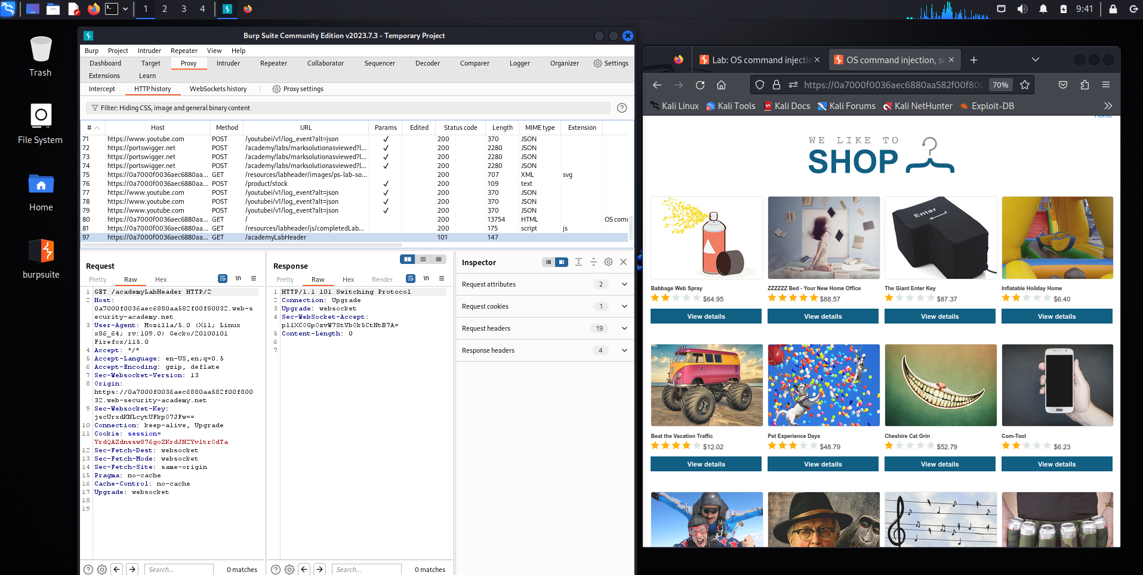

The request is intercepted and sent to Burp Suite Community Edition Repeater to manually test the productId parameter. By modifying the value and resending the request, the tester can observe the server’s response and determine whether the input is executed as a system command. This step helps identify potential OS command injection vulnerabilities in the application.
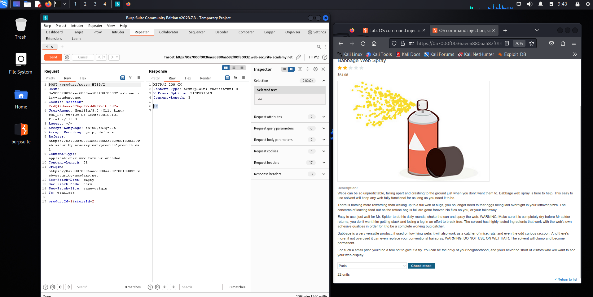

The productId parameter is modified by appending a command payload (;whoami) in Burp Suite Community Edition Repeater. When the request is sent, the server executes the injected command and returns the result in the response, confirming that the application is vulnerable to OS command injection.
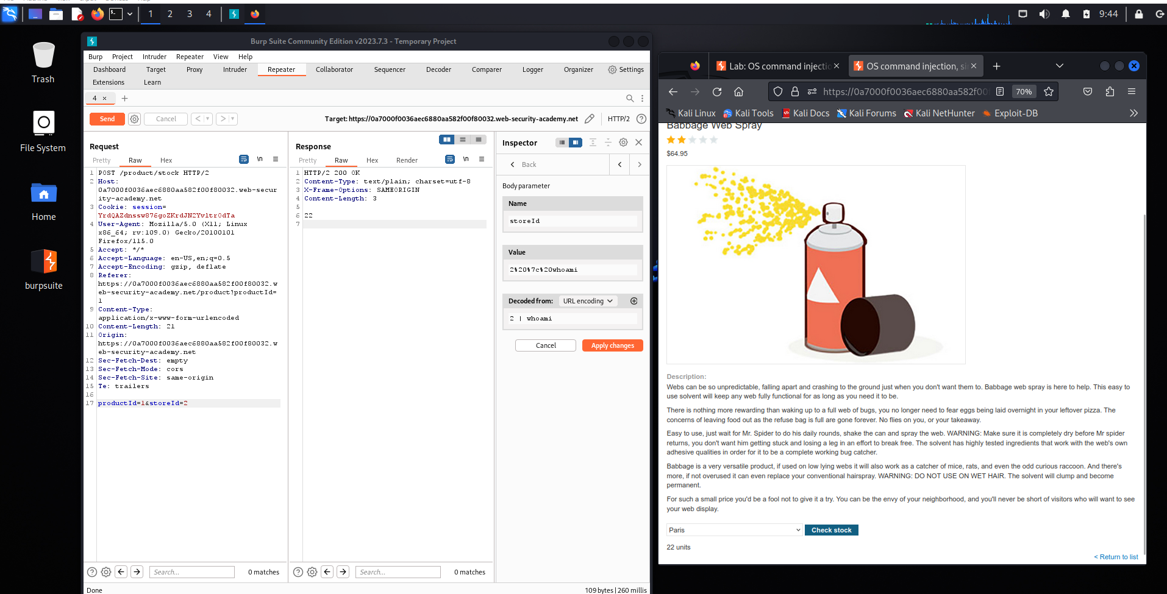

The payload ;whoami is injected into the productId parameter and the request is sent using Burp Suite Community Edition Repeater. The server returns the username peter in the response, proving that the injected system command was executed successfully on the server. This confirms the presence of an OS command injection vulnerability.
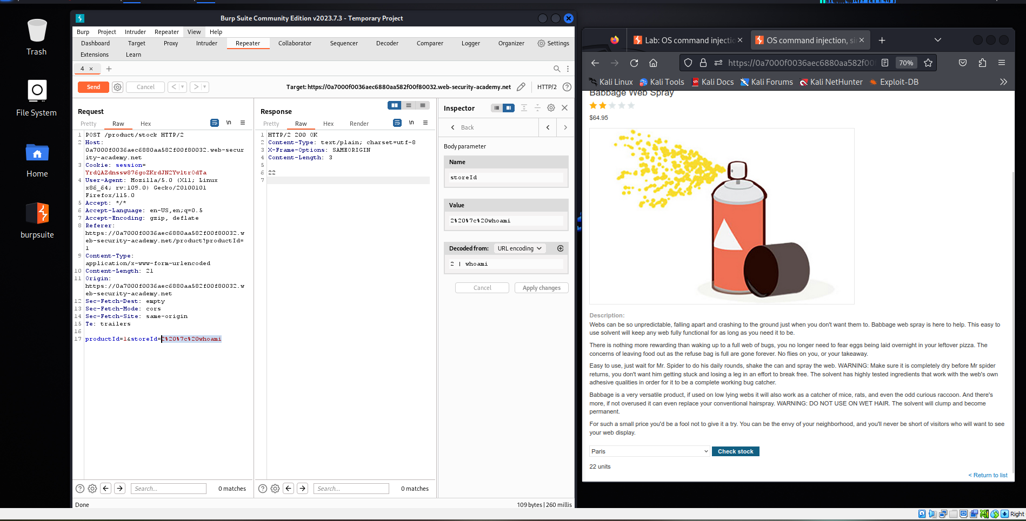
After injecting the payload ;whoami into the productId parameter and sending the request through Burp Suite Community Edition, the server returns the system username peter-bTGmyF. The lab page then confirms that the attack was successful, indicating that the application is vulnerable to OS command injection.
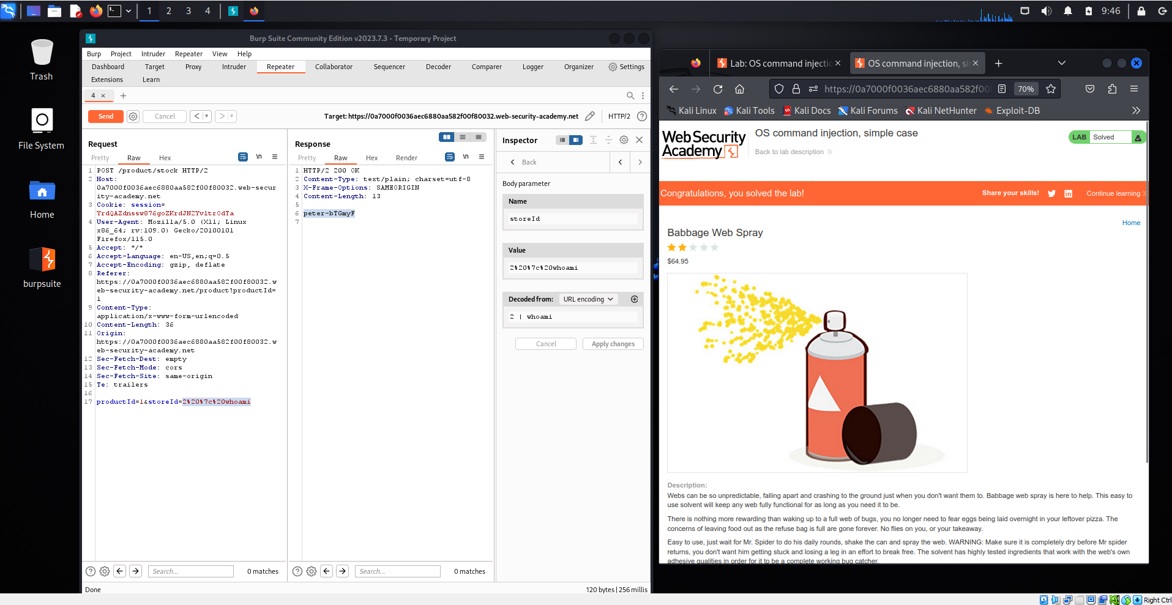

The injected payload ;whoami in the productId parameter is processed by the server, and the response reveals the system user peter-bTGmyF 22. The application then displays a success message from PortSwigger Web Security Academy, confirming that the OS command injection attack successfully solved the lab.
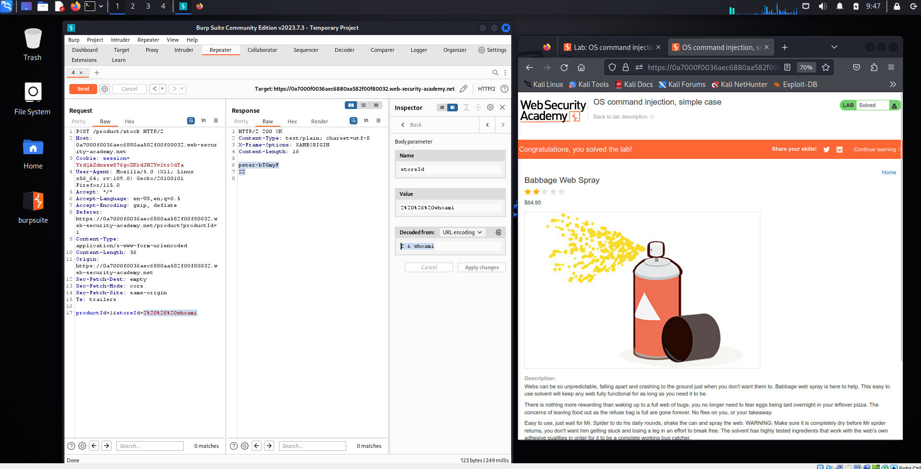
A malicious payload ;whoami is appended to the productId parameter and sent through Burp Suite Community Edition Repeater. The server response reveals the username peter, and the application displays a success notification indicating that the OS command injection vulnerability has been successfully exploited.
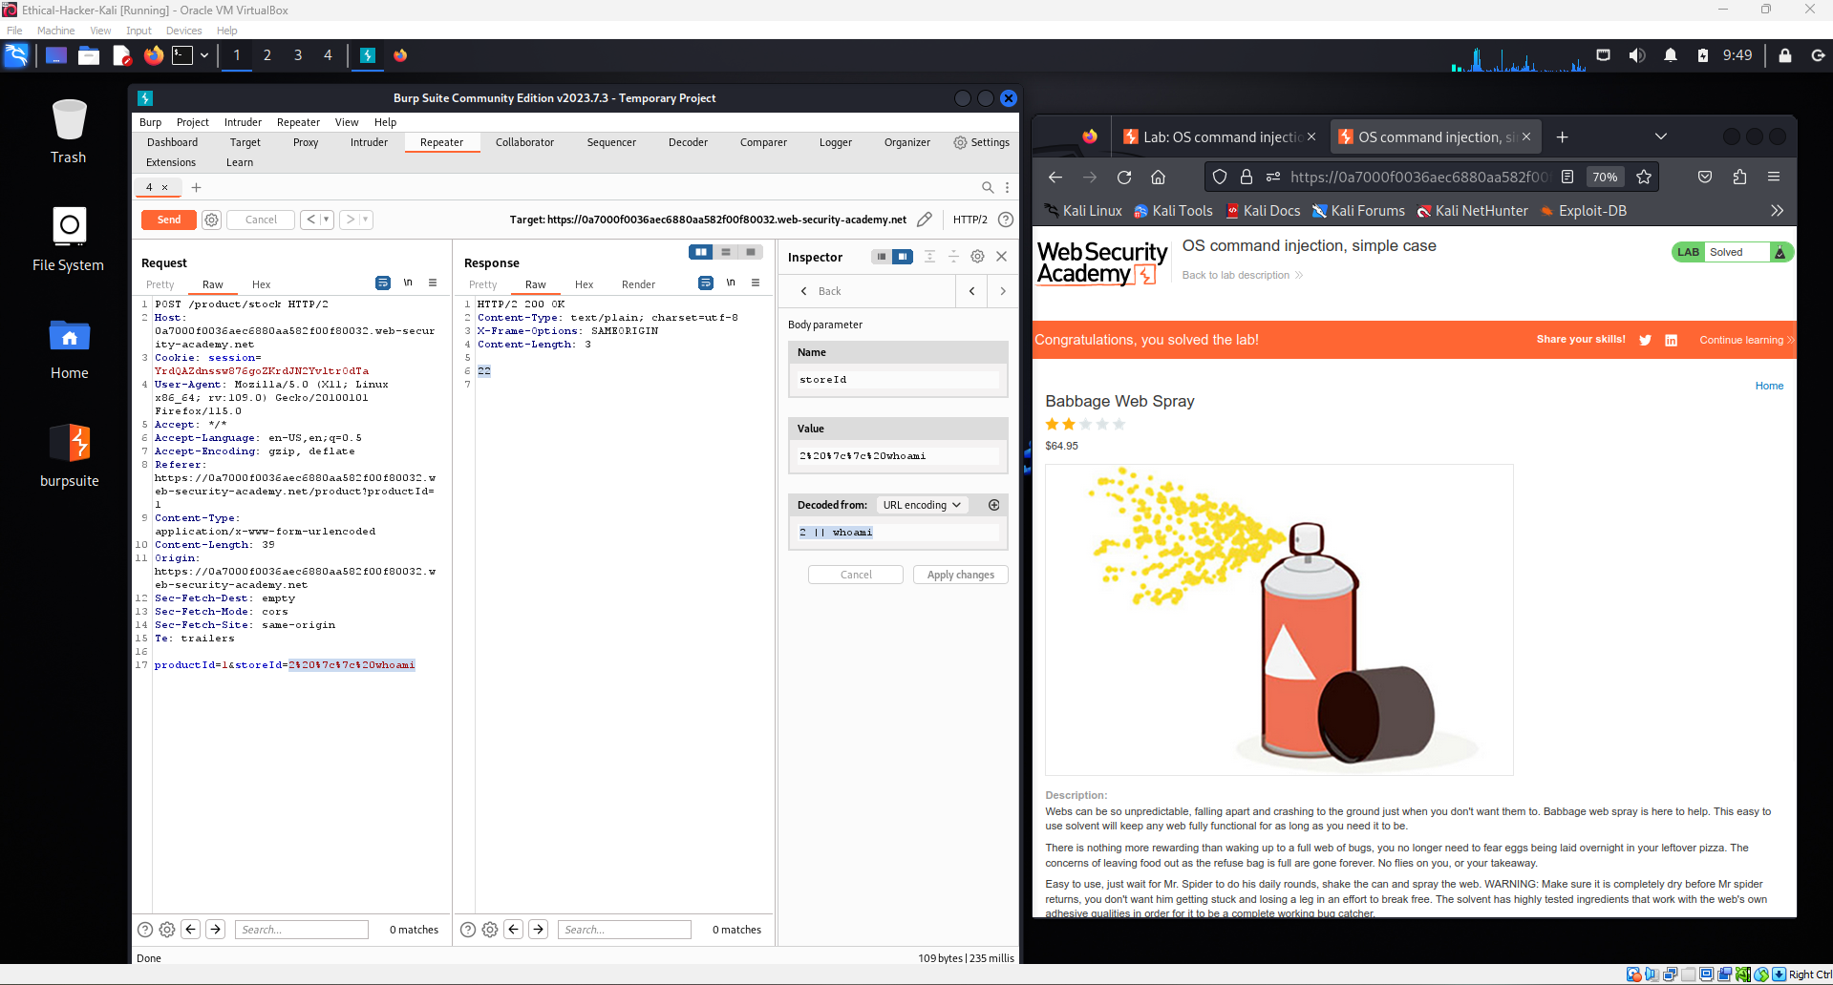

The request containing the payload ;whoami is sent through Burp Suite Community Edition Repeater by modifying the productId parameter. The server processes the injected command and returns the system user peter-bTGmyF 22, confirming that the OS command injection vulnerability has been successfully exploited and the lab is solved.
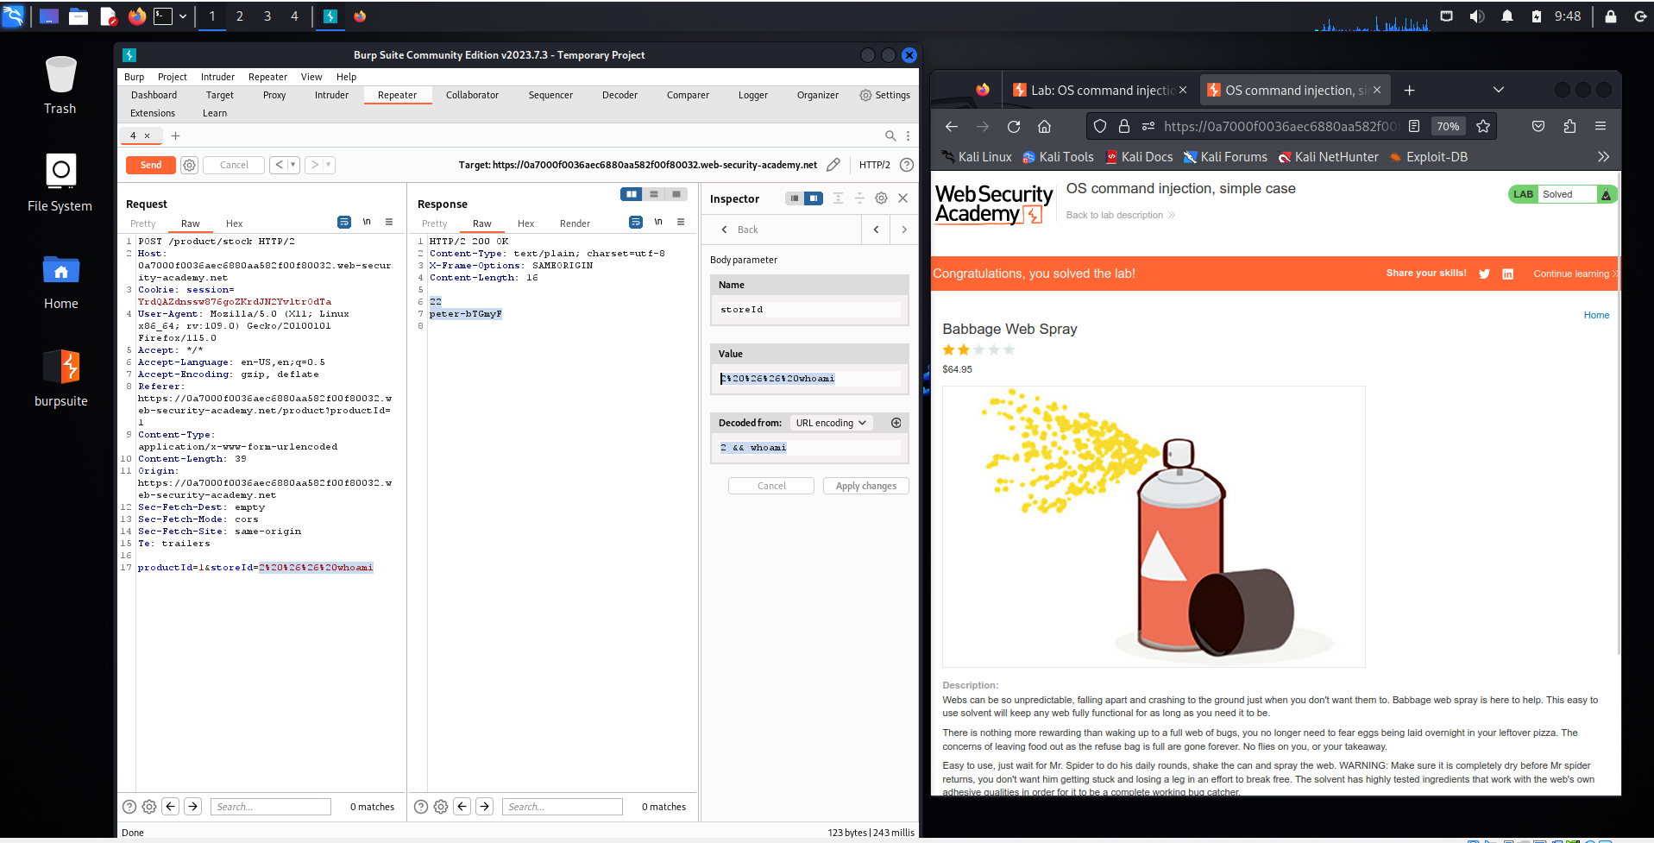

1. What is an OS Command Injection vulnerability, and how does it differ from other types of injection attacks?
An OS Command Injection vulnerability is a security flaw that occurs when a web application allows user input to be executed as part of a system command on the server’s operating system without proper validation or sanitization. This means that an attacker can insert malicious commands into input fields or parameters, and the server will execute them directly in the operating system shell.
This type of vulnerability is different from other injection attacks such as SQL Injection or Cross-Site Scripting. SQL Injection targets a database by manipulating SQL queries, while Cross-Site Scripting injects malicious scripts into web pages that run in a user’s browser. In contrast, OS Command Injection interacts directly with the server’s operating system, allowing attackers to execute system-level commands. Because of this, it can potentially give attackers deeper control over the server compared to many other injection attacks.

2. How attackers exploit this vulnerability and its potential impact
Attackers exploit OS Command Injection by inserting malicious commands into application inputs that are later used by the server to run system commands. If the application does not properly validate or filter user input, the attacker can append additional commands using special characters such as ;, &&, or |. These characters allow multiple commands to run sequentially in the system shell.
For example, if an application executes a command based on user input, an attacker may add another command to retrieve system information. When the server processes the request, both the intended command and the injected command will run. As a result, attackers may be able to view sensitive system data, access restricted files, or even gain control of the server.
The impact of this vulnerability can be very serious. Attackers may:
- Access confidential system files and sensitive data.
- Modify or delete important application data.
- Install malicious software on the server.
- Gain full control of the server depending on the system privileges.
These actions can compromise both the security and data integrity of the application, potentially leading to data breaches, service disruption, and loss of user trust.
Conclusion of the Lab
In this lab, we learned how an OS Command Injection vulnerability can occur when a web application does not properly validate or sanitize user input before passing it to system commands. By intercepting and modifying a request using Burp Suite Community Edition, we were able to inject an additional command into the productId parameter. The server then executed the injected command and returned the system user, which confirmed that the vulnerability existed and could be exploited.
This experiment shows that OS Command Injection is a serious security risk because attackers can execute unauthorized commands directly on the server’s operating system. If exploited in real-world applications, attackers could access sensitive files, modify or delete important data, install malicious programs, or even take full control of the server.
To prevent this vulnerability, developers should follow several security practices. First, all user inputs should be validated and sanitized before being processed by the application. Second, applications should avoid executing system commands directly whenever possible and instead use safer built-in functions or libraries. Third, developers should implement principle of least privilege, meaning the application should run with minimal system permissions so that even if an attack occurs, the damage is limited. Finally, regular security testing and code reviews should be performed to detect vulnerabilities early.
Overall, this lab helped demonstrate both how OS Command Injection works and why secure coding practices are essential to protect applications and maintain data integrity.

